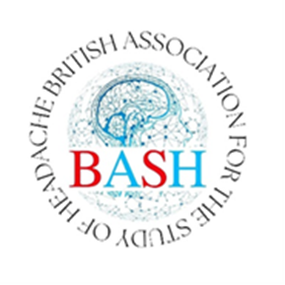

Application Form for role of Honorary Advisor to BASH Council

PLEASE email the completed form to info@bash.org.uk before Saturday 31st August 2024

Job Title:
Honorary Advisor to the British Association for the Study of Headache (BASH) Council (Non-Voting Member)

Job Summary:
The Honorary Advisor to the BASH Council is a non-voting member co-opted by BASH Council to provide expert advice and guidance to the Council on matters related to headache disorders, research, and treatment. This role serves as a valuable resource for the Council, offering insights and perspectives that contribute to the organisation's strategic decision-making and goal-setting processes.

Before applying, please read the Job Description of this role. The proposer and seconder should be BASH members.

Your Name

Your Current Job Title

Your Contact details

Proposer:
Name
Their Role
Their Contact details

Seconder
Name
Their Role
Their Contact details

Please add here a short paragraph outlining your experience in headache disorders, why you would like to be an Honorary advisor to BASH and what your contribution might be.

